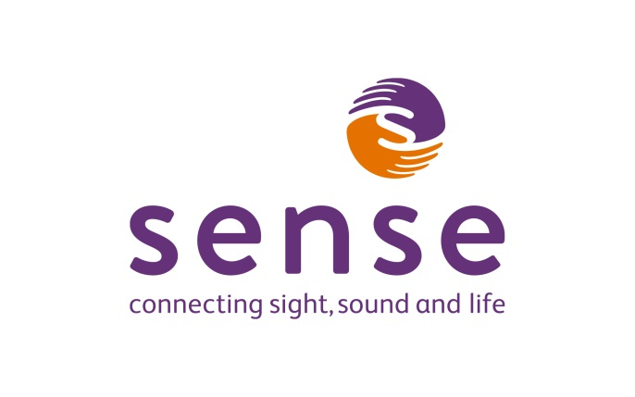
Ice Skating:

Free Taster Sessions on the 22nd Feb and 1st March. We invite you come down and get used to the layout, the smells, the feel of the ice, the coolness and the acoustics of the centre.

Sessions will then be ongoing from the 8th March 2017 in term time with a fee of £7.50 per session.

Additional information to note:

- You can skate independently or with support and even be pushed around in a wheel chair, so everyone can have a go regardless of your support needs
- Arrive to sessions at least 15mins early to get changed and complete any necessary paperwork
- Onsite café
- Please wear lose and comfortable clothing, preferable long sleeve and remember it will be colder in the ice rink area than the rest of the centre
- Please bring a bottle of water with you
- Accessible toilets are available

Getting there:

You can zoom in on the map for a larger view if needed.
https://www.google.co.uk/maps/place/Sobell+Leisure+Centre/@51.5578646,-0.1131407,17z/data=!4m5!3m4!1s0x48761b9e7839725f:0x8f3914e19826a968!8m2!3d51.5588985!4d-0.1120356?hl=en – Google maps

Sobell leisure Centre,
Hornsey Rd,
London,
N7 7NY

From a Tube Station:
The Sobell Leisure Centre is within fairly easy walking distance if you know the area of either Holloway Road tube station on the Piccadilly line or Arsenal tube station also on the Piccadilly line.

It is well known in the area and surrounded by various sports courts for recognition.

By Bus:
This area is well served by many different bus routes depending on where you are coming from.
These are the main routes on Tollington Road (the road which the centre is on): 4, 29, 153, 253, 254, 259
The 91 goes from Hornsey Road which is also the road the centre is on.

The easiest way is to type in the departure and the destination details into the TFL journey planner. This is the link:
https://tfl.gov.uk/plan-a-journey/

TFL also has various forms of accessible guides which you can get for free of charge by ordering them
https://tfl.gov.uk/forms/12387.aspx

By Car:
There is a pay and display car park which always has plenty of free spaces, blue badge parking is free.

