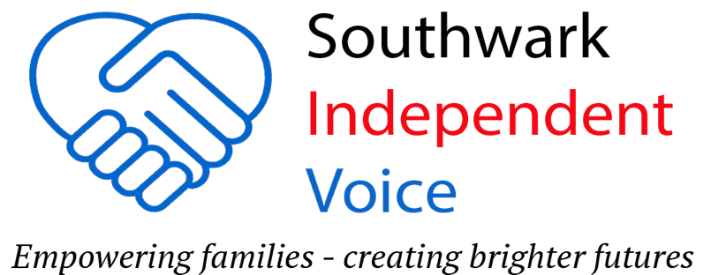

​

**Aged 16 – 25 SEND Social Event!!**

**Saturday 12th April 2025**

**Time: 1pm - 4pm**

**Venue: Peckham (SE15)**

Do you have a young person aged 16-25, with SEND and lives in Southwark?

**Featuring 2 of Heart n Soul's very own DJs!!**

Heart n Soul is an award-winning creative community and arts charity based in South London who believe in the power and talents of people with learning disabilities and autism. Known for their inclusive club nights and diverse musical selections, ranging from funk, reggae to pop and techno!

Free event! To book your place, contact **Nicky: 07999189994**

SIV know young people with SEND can face significant challenges in socialising. This is why we have set up this event so they can get together and have fun.

Limited spaces available so book now!

**Please note: Parents and carers must remain on the premises to supervise their young person.**