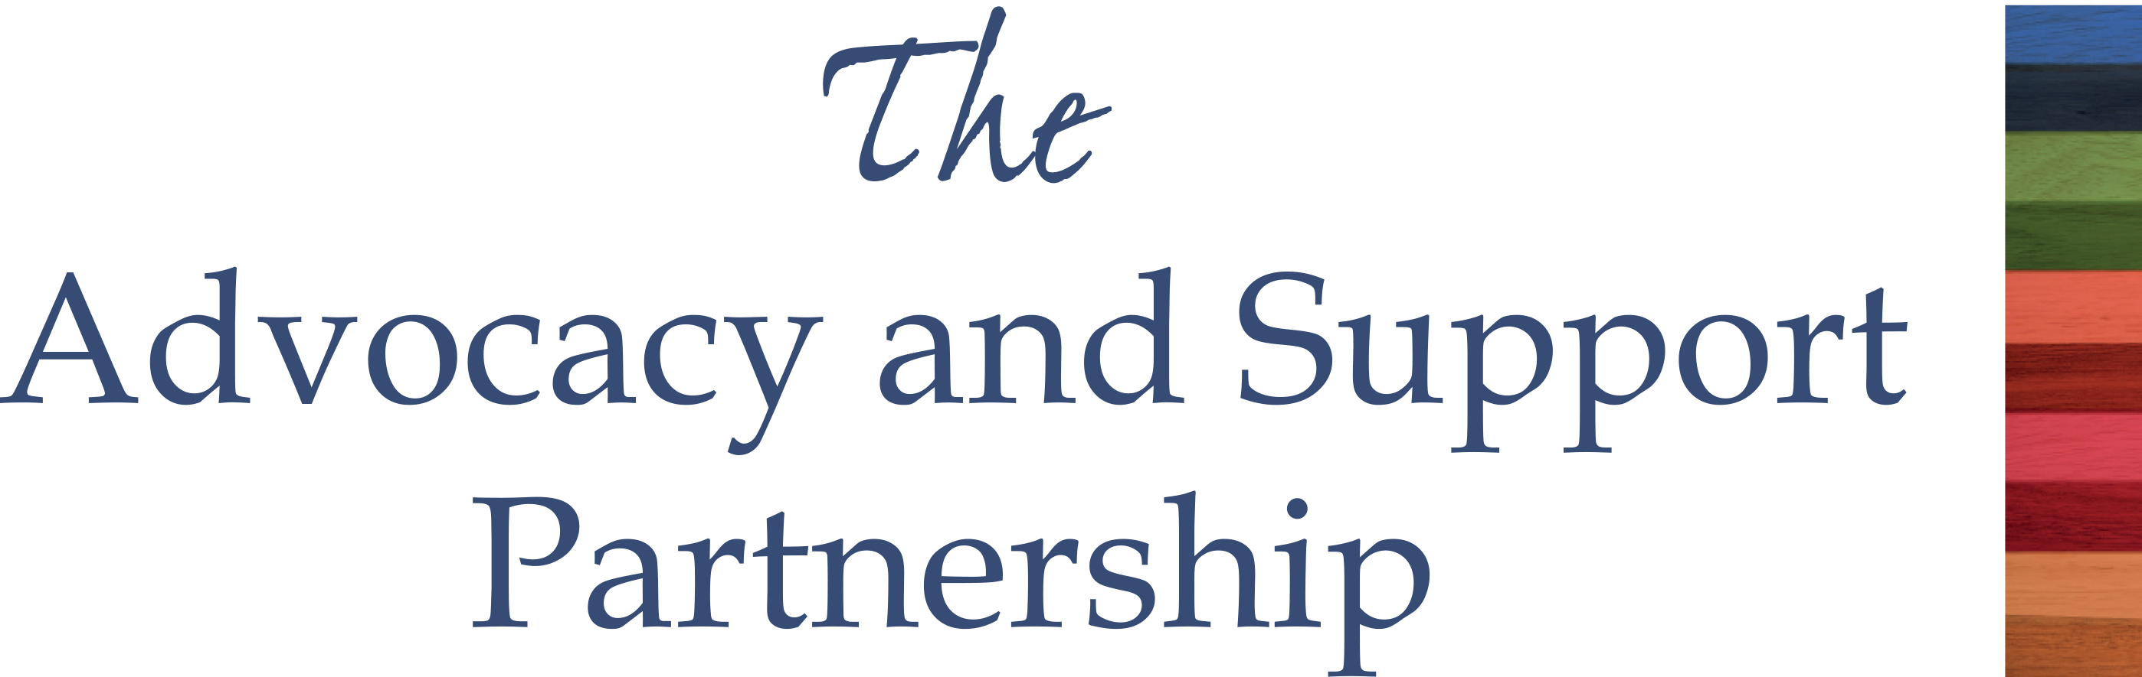

**A Resources for Autism SEMINAR FOR PARENTS, CARERS AND PROFESSIONALS**

**Transition to Adulthood – who pays for the care?**

***Delivered by The Advocacy and Support Partnership***

**Learn how to navigate the system of social care and other services, to get your young person the Care Plan and support they need.**

**Suitable for parents/carers of young people aged 14+, but particularly important for those 16 to 18, or those who are adults already.**

**Free for parents/carers in Southwark and Lewisham.**

**Continuing our theme of rights of disabled children in adult life, come and hear experts from The Advocacy and Support Partnership talk about Transition to Adulthood and how to navigate social care, education, the health service and benefits systems. Join us and learn about:**

* **EHCP and Care Plan: How do education plans link with care plans?**
* **Care Entitlement: What support young adults aged 18+ should receive under the Care Act 2014**
* **Planning for Adult Life: How the Act affects planning for adulthood and what you should be thinking about**
* **Assessment by Social Services: Who gets assessed, and how it helps**
* **Crafting a Care Plan: Making a plan based on assessed needs**
* **Support from Local Authorities: Services local authorities must offer under the Act**
* **Health Service/NHS and IHB Involvement: How healthcare fits into care assessments**
* **Rights of Carers: What rights caregivers have under the law**

**When: Thursday 18th September: 10am-2.30pm**

**Where: The Living Space1 Coral St, London SE1 7BE**

**Refreshments will be provided**

**Booking is essential:** [**nazia@resourcesforautism.org.uk**](mailto:nazia@resourcesforautism.org.uk)