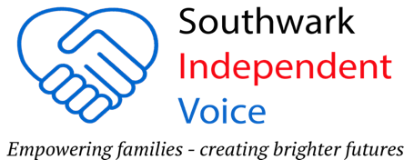

OCCUPATIONAL THERAPY
Penny Noble – Senior Specialist Children’s Community Occupational Therapy and Rebecca Hoffman – Children’s Occupational Therapist

NHS TRANSITION FROM CAMHs TO ADULT SERVICE Danielle Ashley – Clinical Nurse Specialist for Adolescent Health & Transition and Bridget Nichola – Designated Clinical Officer for SEND in Southwark

THURSDAY 25TH SEPTEMBER 2025. 10am until 1pm
VENUE: The Links Community Centre, 353 Rotherhithe New Rd, SE16 3HF

TOPIC – WHAT IS OCCUPATIONAL THERAPY (OT) AND HOW TO ACCESS IT plus AUTISM SERVICE DEVELOPMENT PROJECT

Occupational Therapy is often thought of as a service that helps with a “physical difficulty”, this is true, but it is so much more that. Their role is to help children and young people develop the skills needed to participate FULLY in school and everyday life. This can include fine and gross motor skills, sensory integration, and self-care skills, as well as addressing emotional regulation and social skills.

The Occupational Therapists will explain the ways they can help and how you can access their service plus how to reapply if you have previously had support.

Penny and Rebecca want to hear your experiences to help identify gaps in
support for autistic children and their families throughout their journey from pre-diagnosis to post-diagnosis.

They want to hear from families on how the Occupational Therapy Service can improve their offer for autistic children and their families.

TOPIC – FAMILIES EXPERIENCES OF MOVING FROM CAMHs to ADULT SERVICES

Danielle and Bridget want to hear your experiences of your child’s transition from CAMHs to Adult Services. Did you feel informed and supported? What were the barriers you faced? Do you think there is support during this period and once your child leaves CAMHs? Do you know what happens once your child reaches 18?

Refreshments available – please note our events are for adults only

