Summer Programme

 | Tuesday  6.30pm - 9pm | Wednesday  6.30pm - 9pm | Thursday  6.30pm - 9pm
Week 1  28/7/26 – 30/7/26 | 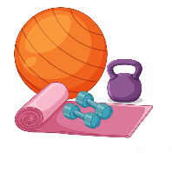  Gym Session @ Camberwell Leisure Centre | Trip | 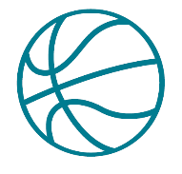  Brandon @ Bethwin  Adventure Playground
Week 2  4/8/26 – 6/8/26 | Gym Session @ Camberwell Leisure Centre | 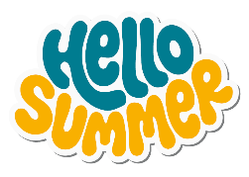  Trip | Brandon @ Bethwin  Adventure Playground
Week 3  11/8/26 – 13/8/26 | 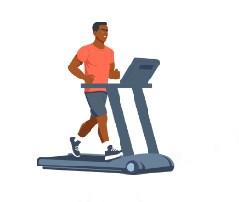  Gym Session @ Camberwell Leisure Centre | Trip | 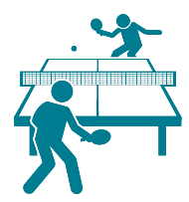  Brandon @ Bethwin  Adventure Playground
Week 4  18/8/26 – 20/8/26 | Gym Session @ Camberwell Leisure Centre | Trip | Closed  Staff Away Day

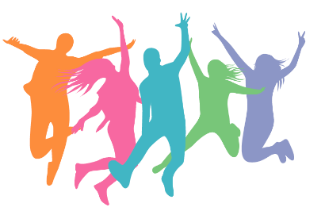
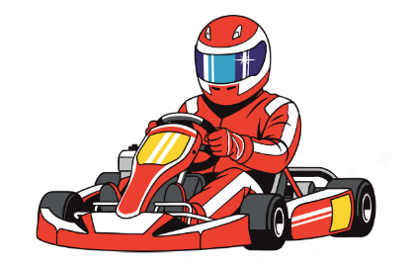
*Programme is subject to change
Brandon Youth Centre
19 Maddock Way
Cooks Road
SE17 3NH
Tel: 02077352506
Mobile: 07729073680

