Summer Programme

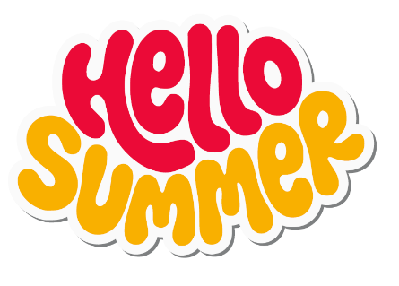
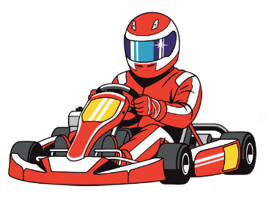
*Programme is subject to change
 | Monday  1pm - 5pm | Tuesday  1.30pm – 5.30pm | Wednesday  1.30pm – 5.30pm | Thursday  1.30pm – 5.30pm | Friday  1pm - 5pm
Week 1  27/7/26 - 1/8/26 | 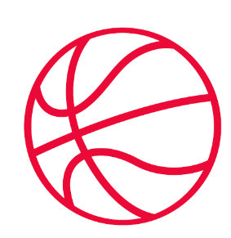  Skyway  Registration  General Youth Club Activities | Registration  Football  Table Tennis  Pool  Multi Sports  Arts & Cratfs | Team Games  Cooking  Arts & Crafts  Multi Sports  Gym | Multi Sports  Arts & Crafts  Gym  Board Games  PS5  Millwall Kicks  2pm-4pm | 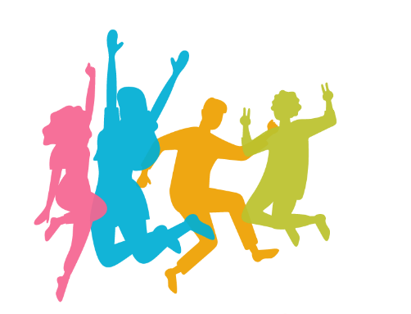  Skyway  General Youth Club Activities
Week 2  3/8/26 - 7/8/26 | Skyway  General Youth Club Activities | Team Games  Multi Sports  Arts & Crafts  Juice bar  PS5  Gym | 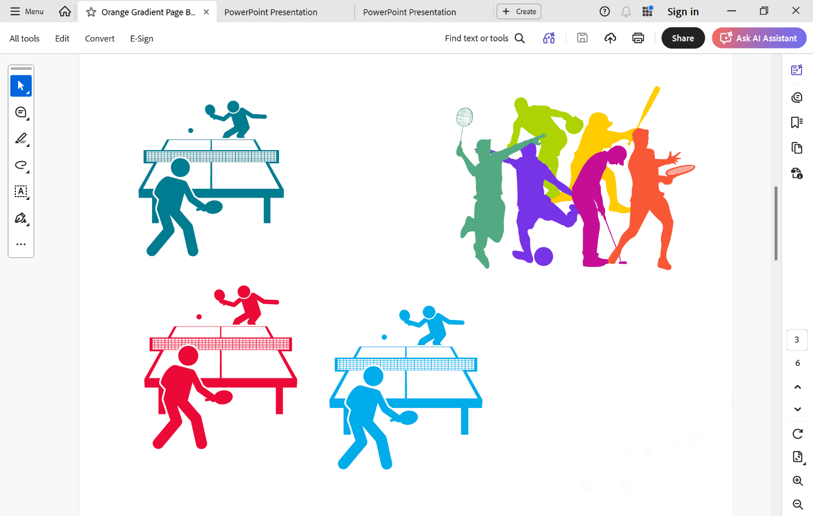  Workshop  Nail Art  PS5  DTC Bingo  Multi Sports  Gym | Multi Sports  Arts & Crafts  Millwall Kicks  2pm-4pm  Gym  Trip | Skyway  General Youth Club Activities
Week 3  10/8/26 – 14/8/26 | Skyway  General Youth Club Activities | Multi Sports  Board Games  Arts & Crafts  DTC Bingo  Gym | Team Games  Multi Sports  Gym | Workshop  Arts & Crafts  Millwall Kicks  2pm-4pm  Gym  Trip | Skyway  General Youth Club Activities
Week 4  17/8/26 – 21/8/26 | Skyway  General Youth Club Activities | Team Games  Ps 5 Competition  7 aside Football competition  Gym | Table tennis Comp  Multi sports  PS5  Gym | Centre Closed |   Skyway  General Youth Club Activities
Damilola Taylor Youth Centre
1 East Surrey Grove, Peckham,
SE15 6DR
Tel: 0207 703 9996

Damilola Taylor Youth Centre
1 East Surrey Grove, Peckham,
SE15 6DR
Tel: 0207 703 9996
-

