Summer Programme

 | Tuesday  1.30pm – 5.30pm | Wednesday  1.30pm - 5.30pm | Thursday  1.30pm – 5.30pm
Week 1  28/7/26- 30/7/26 | 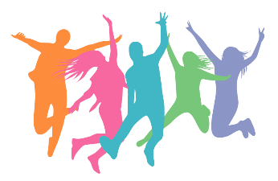  Registration  Wellbeing session  Sexual health workshop | Registration  Generic activities | 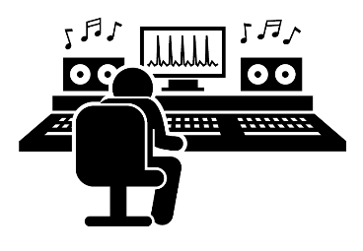  Registration  Generic activities  Music production workshop
Week 2  4/8/26 - 6/8/26 | Games  Competition (Basketball, PS5, Table tennis & Pool)  Career advice & workshop  Circuit training & healthy living | 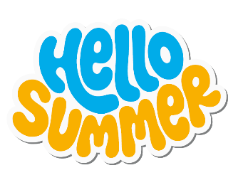  Off-site trip 1 | Youth Gambling Awareness Workshop  Music Workshop  Games Competition  (Basketball, PS5 Table tennis & Pool)
Week 3  11/8/26 – 13/8/26 | 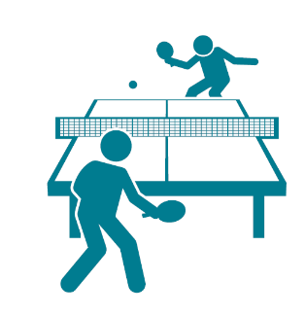  Career & advice workshop  Circuit training & healthy living  Games  Competition (Basketball, PS5 Table tennis & Pool) | Off-site trip 2 | 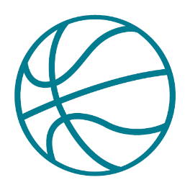  Games Competition  (Basketball, PS5 Table tennis & Pool)  Nails Art
Week 4  18/8/26 – 20/8/26 | Music production workshop  Games  Competition (Basketball, PS5 Table tennis & Pool) | 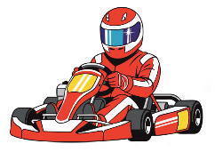  Off-site trip 3 | Staff Away Day

*Programme is subject to change

