

# VISION IMPAIRMENT TEAM NEWSLETTER

### **Reading for pleasure**

Easy Reader is a free app which allows your child to choose a format for reading which is accessible for them. Information can be found on the RNIB website:

<https://www.rnib.org.uk/rnibconnect/easyreader-app>

Your child/young person will need a Bookshare account. If you are unsure of their log-in details or whether they have an account, contact Anne Webster on: 07568135334 [anne.webster@southwark.gov.uk](mailto:anne.webster@southwark.gov.uk)

While schools remain closed, “Audible” after offering hundreds of children’s audio books for free. See below:

<https://www.audible.co.uk/cat/Children-Audiobooks/535836031>

## **Touch Typing**

Touch typing is a life skill which you and your child/young person may be interested in.

Below are links to touch typing programmes you could choose from:

<https://www.doorwayonline.org.uk/typing/>

(free)

<http://www.iota.co.uk/touchtype/index.html>

(cost of £38.50)

**Top tips**

* Find the ridges on the keys f (with the left hand) and j (with the right hand) so that vision is not needed to find them.
* Place index fingers on the above keys and the remaining middle, ring and little fingers of each hand on the keys next to them.These are the home keys. The appropriate fingers should always be brought back to these keys.
* Aim for short bursts of touch typing, around 15 minutes at a time.

# Issue 1: 24.02.20

**Update**

As we continue in the lockdown, the Vision Impairment Team continue to work on behalf of your children and young people. We are available for telephone/email support Monday-Friday 9am-5pm (see details at the bottom of this newsletter). Look out for fortnightly newsletters from the team. Included in this newsletter are suggestions and links which may be of interest to you and your children but please do not feel that they need to be added to your already busy schedules. You can dip in and out if you so choose.

fdfddd

**Contacts**

Susan King O’Neill: susan.kingo’neill@southwark.gov.uk; 07956766333

Anne Webster: [anne.webster@southwark.gov.uk](mailto:anne.webster@southwark.gov.uk); 07568135334

Sakeena Adamjee: [sakeena.adamjee@southwark.gov.uk](mailto:sakeena.adamjee@southwark.gov.uk)

Karen Walsh: karen.walsh@southwark.gov.uk

**Ideas/Suggestions**

If you would like any further information or wish to share resources with other families, please get in touch and we can include these in future newsletters

**Webinars**

Dolphin are a company that creates software to allow people with visual impairments to gain access to computers at home and at school. They are offering regular free webinars. Some are for education professionals but many are for parents and children/young people using equipment or apps for those with vision impairments:

<https://yourdolphin.com/en-gb/webinars?filterBy=upcoming&sortBy=startTime&sortDescending=false>

**Braille Bar Zoom sessions**

A variety of Zoom sessions sharing tips on areas such as brushing up on braille skills to cooking for braillists.

To sign up for notifications: <http://braillists.org/newsletter/signup/> 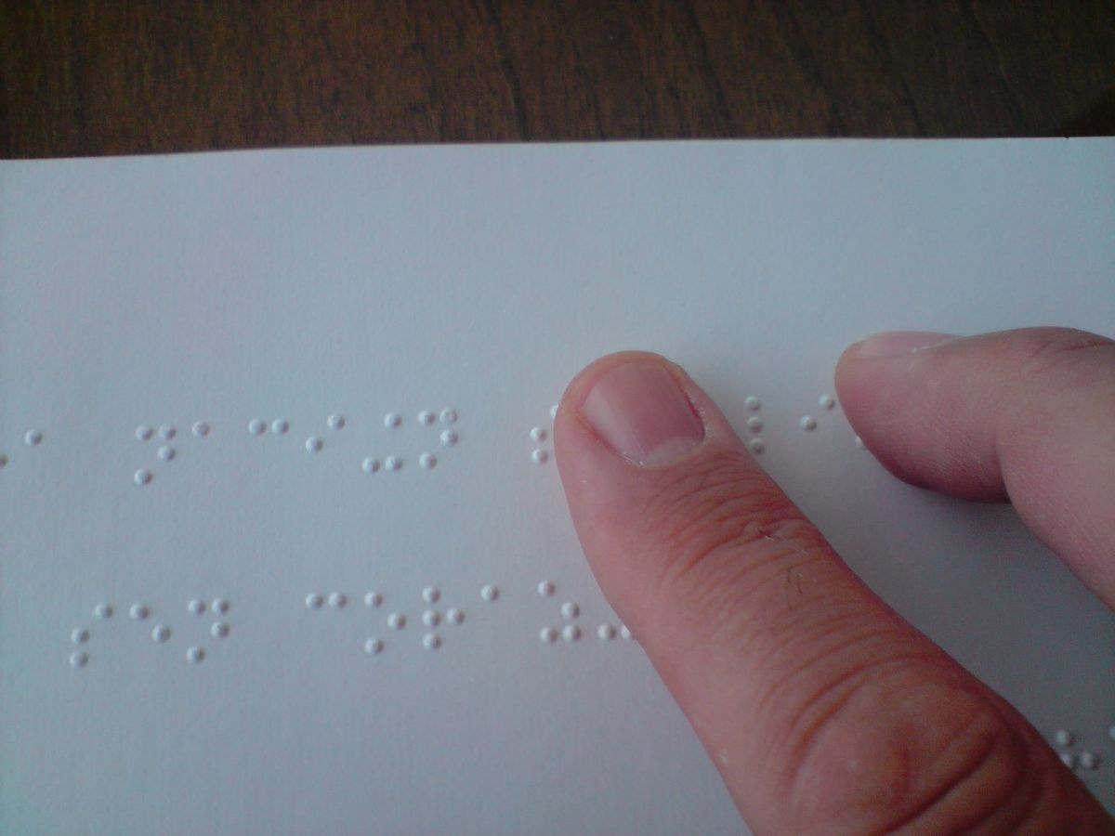

Coping with Covid 19

A book for younger children: 

Calm Zone from Childline is an online toolbox designed to help children cope with the current crisis. It includes ways to cope videos, breathing exercises, activities and tools, yoga videos and games.

<https://www.childline.org.uk/toolbox/calm-zone/>

 Artist and illustrator **Manuela Molina**has produced a PDF booklet that may help start a good shared conversation with a child. The PDF in English can be downloaded from her website [here](https://660919d3-b85b-43c3-a3ad-3de6a9d37099.filesusr.com/ugd/64c685_319c5acf38d34604b537ac9fae37fc80.pdf).