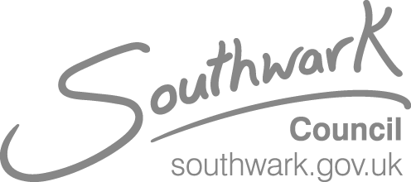

# VISION IMPAIRMENT TEAM NEWSLETTER

**Issue 2: 08.05.20**

**Update**

As we continue in the lockdown, the Vision Impairment Team continue to work on behalf of your children and young people. We are available for telephone/email support Monday-Friday 9am-5pm (see details at the bottom of this newsletter

**Help with technology equipment:**

[www.getonlineathome](http://www.getonlineathome) is a website offering computers, laptops and tablets at a reduced rate. If you are in receipt of benefits there are also further reductions.

Coping with Covid 19

Calm Zone from Childline::

<https://www.childline.org.uk/toolbox/calm-zone/>

Another booklet for children:

<https://nosycrow.com/wp-content/uploads/2020/04/Coronavirus-A-Book-for-Children.pdf>

https://www.surveymonkey.co.uk/r/3P3583B

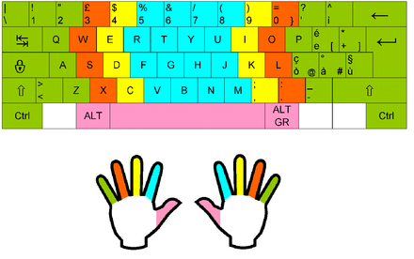

## Touch Typing Reminder

In case you missed it last week, a reminder that touch typing is an important life skill which benefits children and young people.

Below are links to touch typing programmes you could choose from:

<https://www.doorwayonline.org.uk/typing/>

(free)

<http://www.iota.co.uk/touchtype/index.html>

(cost of £38.50)

## Large print keyboard stickers

For those children not learning to touch type, large print stickers for keyboards can help to reduce the need to get close to the keyboard to see the keys.

RNIB stock them for £9.59 in black on yellow:

<https://shop.rnib.org.uk/large-print-keyboard-stickers-black-on-yellow.html>

or white on black:

<https://shop.rnib.org.uk/large-print-keyboard-stickers-white-on-black.html>

|  |
| --- |
| **Survey for Parents and carers of vision impaired children on the impact of Covid19 on Education and Children’s Services** |
| <https://www.surveymonkey.co.uk/r/3P3583B> |

**Braille Bar Zoom sessions**

Sessions continue in areas such as cooking skills and accessing entertainment:

To sign up for notifications: <http://braillists.org/newsletter/signup/> 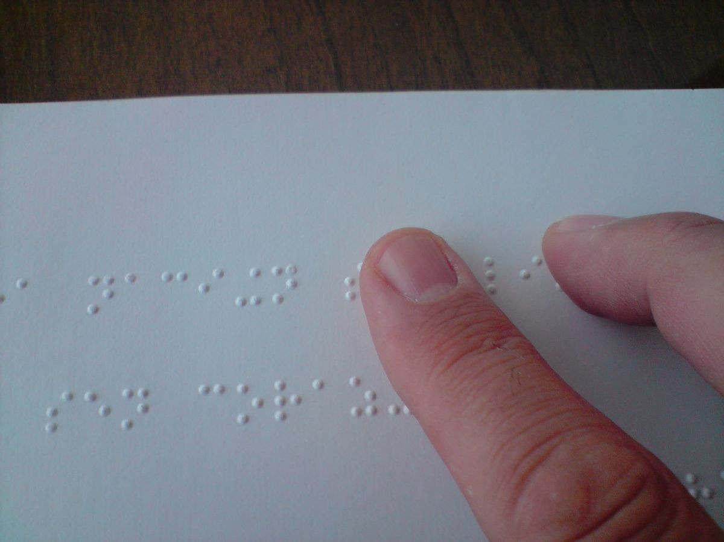

**Calling all budding poets:** 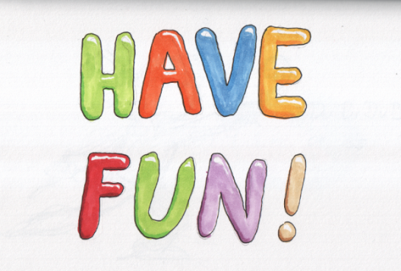

Entries are now open for Foyle’s Young Poet of the Year 2020 for 11-17 year olds. Entries will be accepted in Braille and BSL. Contact [fyp@poetrysociety.org.uk](mailto:fyp@poetrysociety.org.uk)(<mailto:fyp@poetrysociety.org.uk>)  for more information. Get creative and enter by [midnight on 31 July 2020](x-apple-data-detectors://20). Full details here (<https://foyleyoungpoets.org/rules/>)

**Want to get creative?**

Kat from Arts Generation demonstrates a fun imaginative art activity, using recycled plastic drinks bottles. **This  activity should not be carried out unsupervised.** . Adult support is required to prepare the bottles ready for painting. (Acrylic paint is the most suitable paint- don't forget to wear an old shirt or apron- but poster paint mixed with PVA glue will work) The film shows the use of sharp scissors, so children must be supervised or assisted with some of the activity. However, blunter children's scissors can be used to cut more flimsy plastic bottles.

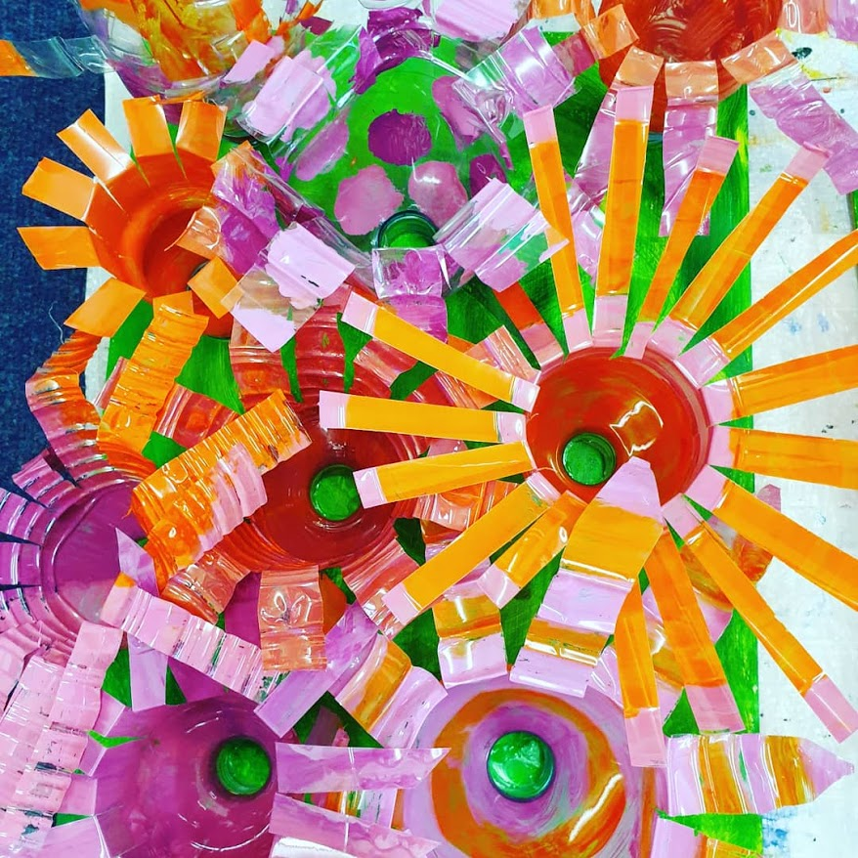

<https://www.artsgeneration.com/video-tutorials>

<https://www.youtube.com/channel/UCSbf1FmaatOJPWJgbLAVlhw?view_as=subscriber>

Instagram arts_generation_

**Ideas/Suggestions**

If you would like any further information or wish to share resources with other families, please get in touch and we can include these in future newsletters

**Contacts**

Susan King O’Neill: susan.kingo’neill@southwark.gov.uk; 07956766333

Anne Webster: [anne.webster@southwark.gov.uk](mailto:anne.webster@southwark.gov.uk); 07568135334

Sakeena Adamjee: [sakeena.adamjee@southwark.gov.uk](mailto:sakeena.adamjee@southwark.gov.uk)

Karen Walsh: karen.walsh@southwark.gov.uk