

# VISION IMPAIRMENT TEAM NEWSLETTER

**FOCUS ON CEREBRAL/CORTICAL VISUAL IMPAIRMENT (CVI)**



**In typical vision, visual signals pass from the eyes through to the visual cortex in the brain where they are processed and interpreted. When there is a problem in the visual cortex these signals cannot be processed correctly and visual information cannot be appreciated. CVI can range from the ability to only notice bright lights in a darkened environment inconsistently to being quite visually aware, e.g being able to fix and focus, track movements and appreciate objects and faces, particularly in quiet settings with reduced distraction.**

Websites with further information:

<https://littlebearsees.org/what-is-cvi/>

<https://cvisociety.org.uk/>

Youtube ideas/videos:

<https://youtu.be/ThAe3Wc3U2o> (explanation from young person’s perspective)

<https://www.youtube.com/results?search_query=richard+hirstwood>+

:

<https://www.youtube.com/playlist?list=PLJ8Cmtr6i0rNTgBclmMermaLGlVutDgbM&fbclid=IwAR32dpfaEqNy5KAt_ktl-rV9CPUTpsHwHWATdP0wuv0O8633qTKNpoUCgp4>

Issue 6: 03.07.20

The Vision Impairment Team continues to work from home on behalf of your children and young people. Contact details can be found at the bottom of this newsletter.

**Apps e-book**

**Henshaws** have produced an e-book of apps costing £3

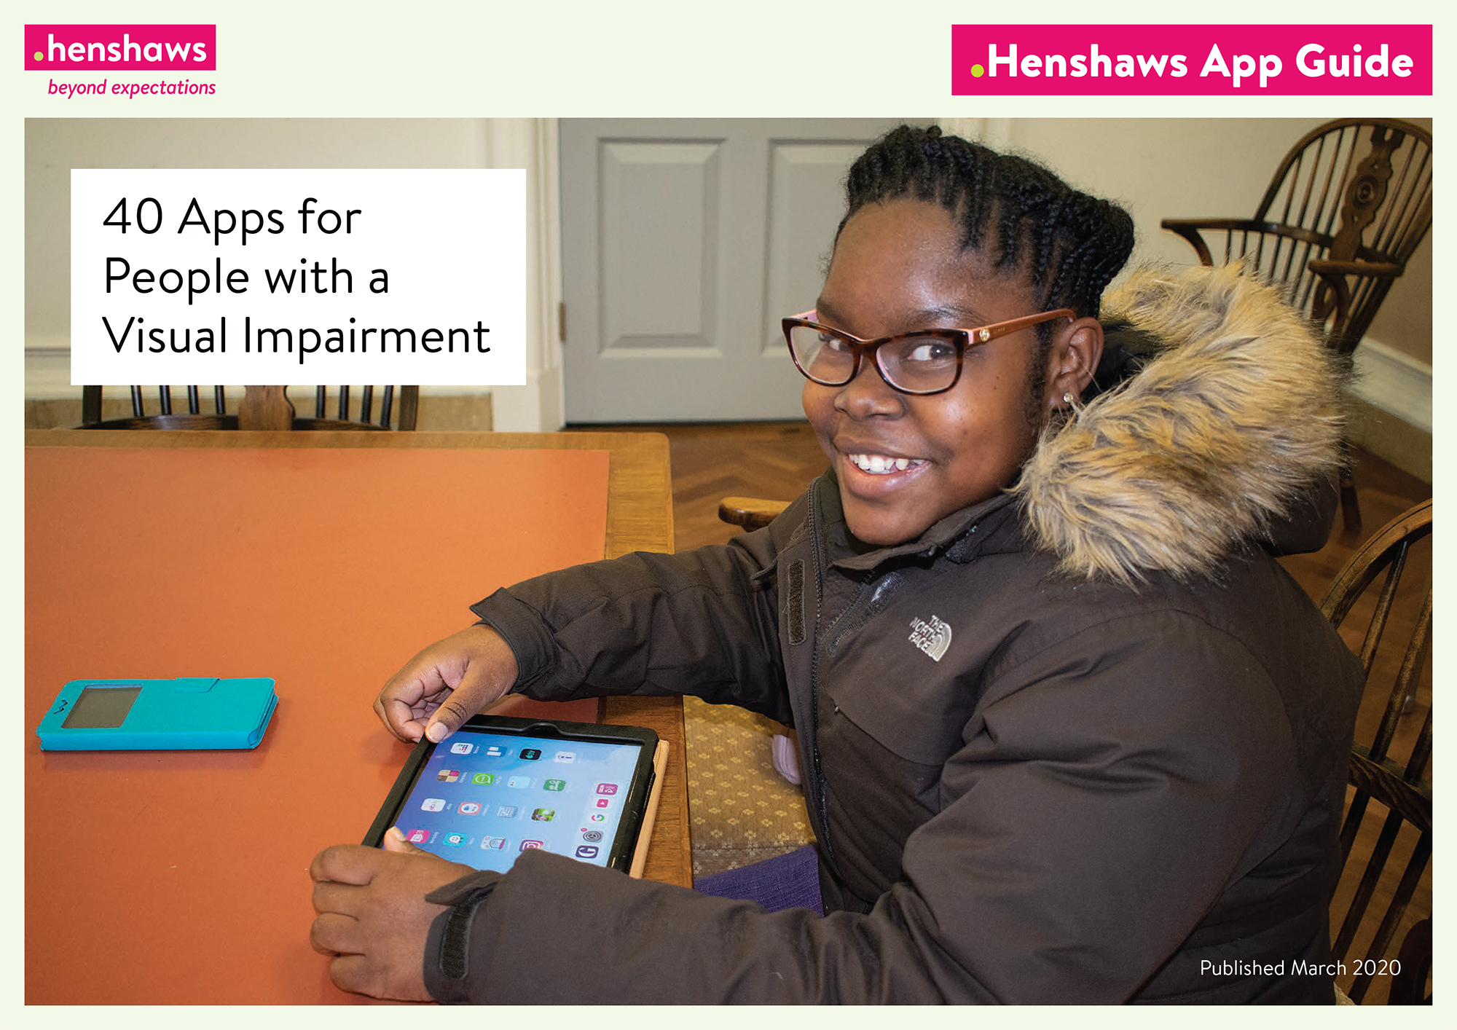

Check the website where you can download a sample pdf or word document here:

<https://www.henshaws.org.uk/shop/ebook/apps-ebook/>



**The LookUK website has regular webinars/zoom sessions, such as this parents’ support group:**

[**https://www.look-uk.org/look-parent-support-group-top-tips-for-survival/**](https://www.look-uk.org/look-parent-support-group-top-tips-for-survival/)

**Check their website for other events/activities**

 **Information for those moving on to university:**

<https://www.pocklington-trust.org.uk/qa-dsa-assessment>

<https://www.pocklington-trust.org.uk/covid-19-student-support>

**Virtual careers fair**

**Although not VI specific, this careers festival may be of interest to some of our young people:**

<https://www.londoncareersfestival.org.uk/>



<https://www.londoncareersfestival.org.uk/>

**Ideas/Suggestions**

If you would like any further information or wish to share resources with other families, please get in touch and we can include these in future newsletters

**Contacts Mon – Fri 9am-5pm**

Susan King O’Neill: susan.kingo’neill@southwark.gov.uk; 07956766333

Anne Webster: [anne.webster@southwark.gov.uk](mailto:anne.webster@southwark.gov.uk); 07568135334

Sakeena Adamjee: [sakeena.adamjee@southwark.gov.uk](mailto:sakeena.adamjee@southwark.gov.uk)

Karen Walsh: [karen.walsh@southwark.gov.uk](mailto:karen.walsh@southwark.gov.uk); 07523920082